**Week Number 1**

**Introduction to Git and GitHub**

**Input Command in Git:** git --version

* Usually, lines with $ in front are our input commands.

**1.To check which version of git is installed we use the command:** git –version

**2. To initialize git on the current folder:** git init

**3. If we want to check the status of git:** git status

**Git:**

* Git is open source.
* Git tracks changes, it can track a state of different versions of the projects.
* Git is a version control system; it keeps track of our code

**GitHub:**

* Hosting provider
* GitHub is a version control platform
* GitHub is a service that lets us host, and share files on the internet

Now to see if Git was installed on my laptop, i typed the command git version on my laptop.

I already had a GitHub account made, so i simply connected my git to GitHub.

**Now some commands in git are:**

**Git commits:**

It basically records snapshots of all the files in the directory (works as copy paste)

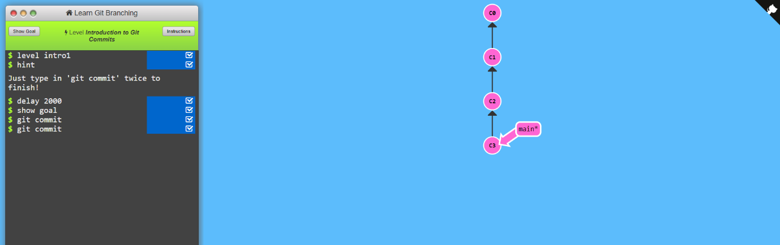

**Git Branch:**

These are pointers to gits

**Git Merge:**

Merging creates a commit that has two unique parents.

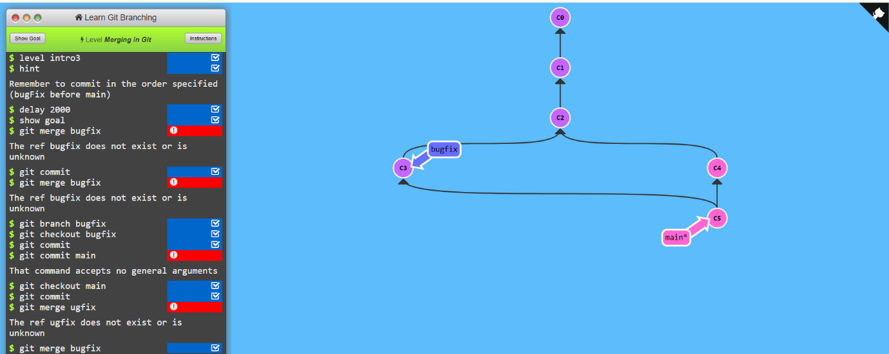

**Data Science VS. Artificial Intelligence VS. Machine Learning VS. Deep Learning**

**DATA SCIENCE:**

Data Science is all about data. It is used in something called prescriptive analytics.

**ARTIFICIAL INTELLIGENCE:**

Ability of Machines to understand, learn and make decision based on data. It enables machines to adapt and and understand relationships between different types of data.

**MACHINE LAEARNING:**

It is a sub-set of AI. It is an implementation of AI. In Machine Learning there are 4 different methods: supervised learning, non-supervised learning, semi-supervised learning and reinforced machine learning. The user basically gives the machine input and feeds the predicted output into it. The machine is supposed to learn the relationship between the input and the output. It trains on a data set and then is tested on some data which is new to the machines, This is a like a test case.

**DEEP LEARNING:**

This is an advancement of Machine Learning. We use Deep Learning when we have large amounts of data to train and the data has too may features. It uses a much more powerful jardware and takes significantly more time.